**SCALE-MODE CALCULATOR**

**Design Considerations**

The calculator is purposed to provide songwriters with associated chords to named scales/modes in any key to notes that the user supplies. This will be within the context of the Western Classical tradition of [12-note equal temperance](https://www.britannica.com/art/equal-temperament).

* I have chosen to identify each key of the tables manually by a 2/3-digit key ([1]11, [2]12, [1]13,…). This will allow easier programming code to identify and access keys/notes due to the absence of leading zeros. The advantage of this is that coders will be able to interpret scale/mode names, keys, notes and chord types like as in a telegram type format from all tables as follows:

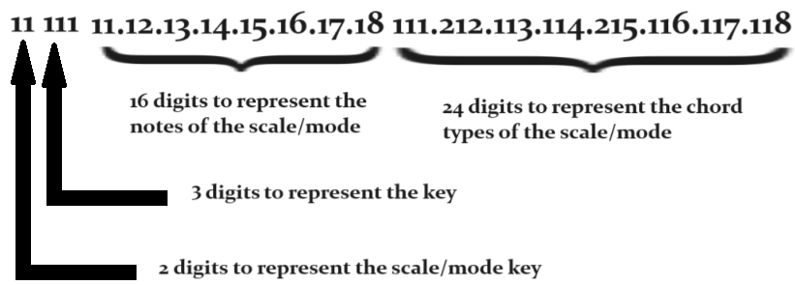

In hindsight the key will be represented by only 2 digits. The 3 digits of the chord types will suffice for the purposes to be implemented.

Since key names and note names are identical, they can be stored within one table. This table would be the primary table to which all queries will relate.

(Table shown on next page)

**Key-Note Table**

|  |  |
| --- | --- |
| **Index PRIM** | **Key-Note** |
| 11 | A |
| 12 | Bb |
| 13 | B |
| 14 | C |
| 15 | Db |
| 16 | D |
| 17 | Eb |
| 18 | E |
| 19 | F |
| 20 | Gb |
| 21 | G |
| 22 | Ab |
| 23 | Eb |

* The Chord Type table will be indexed manually with 3 digits. This will allow types to be grouped together (dominant, major, minor, diminished & augmented, altered and suspended). The 1st digit needs a little explanation. Chords consist of triplets of notes. In Western Classical tradition for example the root chord C-major consists of the notes C, E, G from the C-major scale. These notes are taken from the  for the C-major scale is D-minor (D, F, A). These notes are taken from the 2nd, 4th and 6th notes of the scale (C, D, E, F, G, A, B). Now some chords are almost impossible, or are too complex, to define. Looking at a concrete example; The Chinese scale in C consists of the notes C, E, F#, G, B. Now the second chord of this scale would consist of E, G & C. In relation to the second note this chord could be expressed as E-min #5. But these are the same notes as the C-major chord so why not just substitute an inversion starting at E on the piano keyboard? To signify such a substitution, we can make the first digit of the table’s key to be 2.

**Chord-Type Table**

|  |  |
| --- | --- |
| **Index PRIM** | **Chord Type** |
| 111 | 6 |
| 112 | 7 |
| 121 | maj |
| 122 | M7 |
| 123 | mM7 |
| 131 | min |
| 132 | min4 |
| 133 | min7 |
| 141 | dim |
| 142 | aug |
| 151 | alt b |
| 152 | alt # |
| 160 | sus |
| 161 | sus b2 |
| 162 | sus2 |
| 163 | sus2/4 |
| 164 | sus4 |
| 165 | sus #4 |
| 166 | sus6 |
| 167 | sus7 |
| 168 | sus4/6 |
| 169 | sus4/7 |

* The Scale/Mode table will consist of the 70 or so scales and modes along with the intervals between each note in the scale and chord types. This will facilitate the naming of notes and chords from the other tables arithmetically from the notes inputted by the user. The inclusion of an asterisk (*) informs the user of a inversion or substitute (*see Chord-Type Table*).

**Scale-Mode Table (First 4 records only shown)**

|  |  |  |  |  |  |  |  |  |  |  |  |  |  |  |  |  |  |
| --- | --- | --- | --- | --- | --- | --- | --- | --- | --- | --- | --- | --- | --- | --- | --- | --- | --- |
|  |  | **Intervals** | | | | | | | | **Chord Type** | | | | | | | |
| **Index PRIM** | **Scale/Mode Name** | 1 | 2 | 3 | 4 | 5 | 6 | 7 | 8 | 1 | 2 | 3 | 4 | 5 | 6 | 7 | 8 |
| 1 | Bebop Dominant | 2 | 2 | 1 | 2 | 2 | 1 | 1 | 1 | maj | min | dim | Alt b | *1sus7 | *8 min7 | *1 7 | dim |
| 2 | Bebop Dorian | 2 | 1 | 1 | 1 | 2 | 2 | 1 | 2 | dim | *4 min7 | *57 | dim | maj | min | dim | alt b |
| 3 | Bebop Major | 2 | 2 | 1 | 2 | 1 | 1 | 2 | 1 | maj | dim | min4 | dim | sus2/4 - or –  *7 min7 | dim | min | dim |
| 4 | Bebop Melodic Minor | 2 | 1 | 2 | 2 | 1 | 1 | 2 | 1 | min | dim | alt b | dim | sus2/4 - or –  *7 min7 | dim | dim | dim |